# Conversion of Information Expressed Symbolically

Original Document Alternative Format (HTML)

The first example made using sub-script in PowerPoint – conversion not accurate

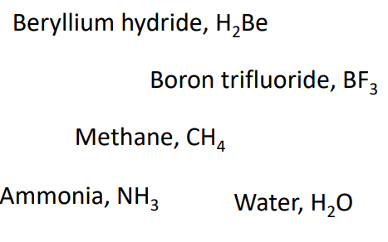 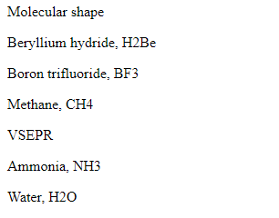

This example made using MS PowerPoint equation editor – no conversion

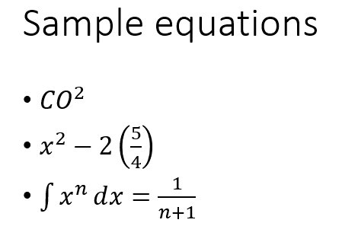 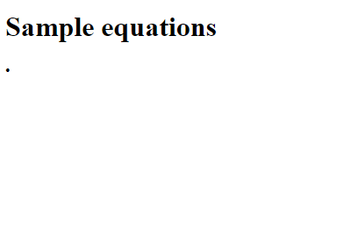

This example made using Latex – conversion not accurate

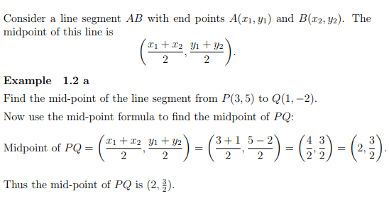 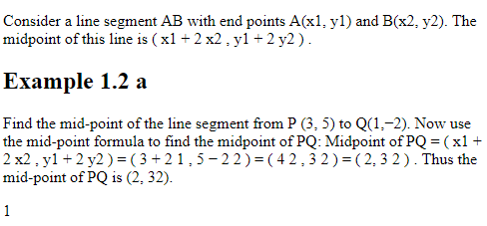

This example made using MS Word equation editor – no conversion

