Student Name: Date:

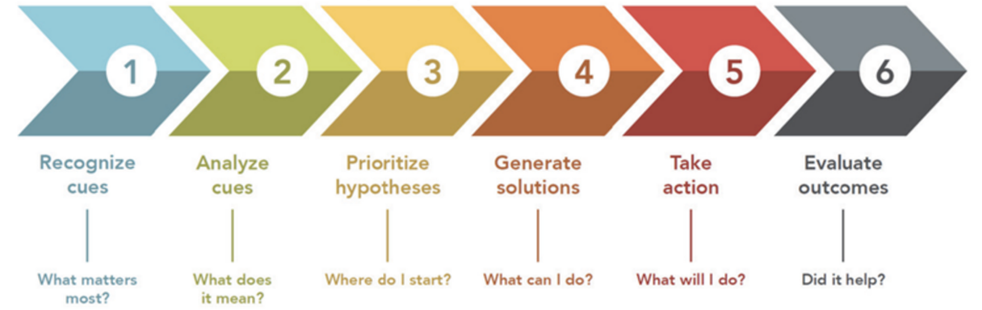
Focused Client Information

Admitting Medical Diagnosis and the related GTC nursing concept(s):
This is the admitting diagnosis and related GTC nursing concept(s) for your client.

Is the admitting diagnosis and nursing concepts still the priority issue for this client? If not, what is and how did this become the priority issue? Note: you will use the updated priority client diagnosis and related concept(s) for the remaining clinical documentation.

If the client came in with heart failure, is heart failure still the issue that they are dealing with, or do they now have a pulmonary embolism that is the priority medical diagnosis?

Pathophysiology of the priority medical diagnosis:

Clinical Judgment Step 1: Recognize Cues
Pertinent Assessment Information related to the priority medical diagnosis:

Focus here on the assessment data related to the highest priority issue for the client. If they are in for heart failure think of things like crackles, edema, dyspnea etc. If their major issue is a PE, think of chest pain, decreased pulse ox, etc.

Pertinent Lab Values for the priority medical diagnosis:

List out the pertinent lab values related to the major issue and what they indicate. For a heart failure client, if their BNP is 1000 then that indicates that they are having an acute exacerbation. If their H&H is normal, then please do not list it here.

Pertinent Diagnostics for the priority medical diagnosis:

EKGs, CXRs, CTs, MRIs, etc., that are related to the diagnosis or the priority issue should be listed here with a brief description of the findings.

Medications related to the priority medical diagnosis:

This should not be a comprehensive list of medications, but a list of the medications that are related to their priority issue and what they do, including prn medications. For example, if an individual is in for heart failure, then Lasix should be listed if they are on that medication. However, if they are on a medication for osteoarthritis, and that is not why they are in the hospital, then don’t list that medication. Note: A medication profile should be completed for each of these medications

Rank your client problems in order of importance for your client:

Clinical Judgment Steps 2-6
Step 2 & 3: Priority Nursing Concept 1  This should be the most pertinent and important nursing problem for the client. | Assessment Information  What assessment information is directly related to this problem
Step 4 & 5: Plan and implement appropriate nursing intervention(s)
What will you do for the client related to this problem? Use SMART patient related goals to structure the plan.

Step 6: Evaluation
Were your interventions effective? How do you know?

Step 2 & 3: Priority Nursing Concept 2 | Assessment Information
Step 2 & 3: Priority Nursing Concept 2 | Step 4 & 5: Plan and implement appropriate nursing intervention(s)
Step 2 & 3: Priority Nursing Concept 2 | Step 6: Evaluation

Step 2 & 3: Priority Nursing Concept 3 | Assessment Information
Step 2 & 3: Priority Nursing Concept 3 | Step 4 & 5: Plan and implement appropriate nursing intervention(s)
Step 2 & 3: Priority Nursing Concept 3 | Step 6: Evaluation

Client Group Information (NUR 156 and NUR 253, other courses as needed)

Admitting diagnosis for the clients in your client group:
This should be a brief description of why each of the clients you were assigned for the day was admitted.

Which client did you see first? Why?
Describe what led you to seeing the first client. Was this client your highest priority, or did something make you see a lower priority client first?

Did the priority of your clients at the beginning of the shift change throughout the day? If so, why?
Did a change in client status make one of your other clients become the priority? Describe what happened if this was the case.

What was the most challenging issue in managing your client group? What would you do differently in your day if you could do it over again?

Were there a lot of medications? A client who was incontinent? Changes in client status that required intervention? Reflect here on things that made your day challenging and what you could do differently if something similar were to happen again in order to make your care more efficient.

Reference: National Council of State Boards of Nursing (NCSBN). (2024). Clinical Judgment Measurement Model: A Framework to Measure Clinical Judgment & Decision Making. https://www.nclex.com/clinical-judgment-measurement-model.page

